

**SECP1513-02**

**TECHNOLOGY AND INFORMATION SYSTEM**

**DESIGN THINKING PROJECT REPORT:**

**FOOD WASTE ANALYTICS**

**LECTURER: DR. ARYATI BINTI BAKRI**

**GROUP 8: BRIDGE BUILDERS**

**GROUP MEMBERS:**

|  |  |  |
| --- | --- | --- |
| **Cheng Zhi Min**  **A25CS0050** | **Farah Aisya Binti Jaafar**  **A25CS0218** | **Muhammad Hafizuddin Hakimi Bin Hasmadi**  **A25CS0273** |

**Table of Contents**

**1. Introduction 3**

**2. Problems and Solutions 3**

**3. Team Working and Collaboration 5**

**4. Design Thinking Assessment Points 5**

**5. Design Thinking 6**

5.1 Design Thinking Process 6

5.2 Design Thinking Evidence 8

5.2.1 Sample Work 8

5.2.2 Record of each phase 9

**6. Reflection 20**

**7. Conclusion 22**

**8. Reference 22**

# **1. Introduction**

Food waste is an issue that exists in the canteens at UTM. Preparation of food is done by guessing. Cafeteria staff prepare excess food as well as insufficient food. Eating behaviors among students also keep changing from day to day. Factors contributing to this include students’ preferences as well as class schedules. Food waste results in costs as well as environmental degradation. In this innovation, design thinking will assist us in designing a solution to this food waste problem that only requires technology.  
 Through the promotion of responsible eating and meal planning, the goal of ‘Re-Saji’ is to minimize food waste in the UTM cafeteria. This is done by ensuring that food is actually prepared based on the real data rather than the estimated output. With the use of the mobile reservation application called ‘Re-Saji’, the students are capable of booking their dining time at UTM cafeterias.

# **2. Problems and Solutions**

| **Problems** | **Descriptions** | **Solutions** |
| --- | --- | --- |
| Inaccurate food demand forecasting in UTM cafeterias | Based on our observations at UTM cafeterias and interviews with students, we concluded that food waste often happens because of the inability to forecast food demand precisely and also student dining habits. This is because students’ eating patterns always change depending on their class timetables, personal preferences, and time limitations, so demand is very unpredictable. Currently, UTM cafeteria staff usually prepare food by rough estimation or by past experience. However, this will cause a major problem, which is excess food waste because of over-preparation or food shortages. | Our solution is to design a mobile application for reservation with QR codes. Basically, students have to book their dining time at cafeteria through our mobile application. For each reservation, students will select which UTM campus cafeteria they would like to dine in (e.g., Restoran Rafi), their dining time (e.g., 12:00-1:00pm), and the portion size (e.g., small, standard, large). Then, our mobile app displays the reservation summary and QR code. So, when students arrive at the cafeteria, they scan the QR code to confirm their arrivement. This is to make sure that food is prepared according to real demand instead of estimation. This also reduces the likelihood of food overproduction. |
| Lack of data for planning food preparation and inventory | UTM cafeteria staff may find it challenging to plan the amount of food to prepare, buy ingredients, and so on. This is because they lack a proper way to know the number of students who will come to eat and when the busiest time is on a certain day. | An AI-based data analysis is used to identify demand patterns from reservation data. By learning from historical reservations, the system can predict peak dining times, popular menus, and preferred portion sizes. This helps cafeteria staff prepare food more accurately and reduce overproduction. |
| Students’ inconsistent eating behavior contributes to waste | Food waste comes from meals that students do not finish. Students often take more food than they can finish. When they get busy and do not have a lot of time to eat, they lose their appetite. As for now, there is no system that tells students to be careful of their consumption. Because of this, wasting food becomes something that students do all the time and they do not make it a big deal. This is a problem because it costs a lot of money and it is bad for the environment. For example, food waste leads to more carbon emissions. | We implement a token-based system instead of online payment. For example, each student who uses our app will have 3 tokens first after registering an account. Each time a reservation is done, a token is used to pay for the reservation. After students finish eating, our app will reward them by adding a token to their account if their plate is clean. Otherwise, a token will be deducted from their account if they fail to finish the food that they order. An AI image recognition model is used to analyze the image to identify leftover food. This system encourages students to be responsible for their eating behaviour. A reward or penalty scheme using tokens is employed to influence the eating habits of the students. |
| Limited payment accessibility for some students | Some students may have difficulty paying online every time, which could discourage usage of a reservation system. | Token system replaces online payments, making the app inclusive and accessible while still supporting dining reservations. |

Table 2.1 Problems and Solutions

# **3. Team Working and Collaboration**

To ensure that each one of us had certain tasks to be done in this design thinking, we had the following tasks. For instance, Hakimi was responsible for the editing process of the video. Further, the task of designing the ‘Re-Saji’ mobile application was attributed to Farah, while Zhi Min was tasked with creating the Google Form survey to obtain the required data for the identification of the problems. Lastly, we pooled our resources together to write the reports.

| **Group Members** | **Task Distribution** |
| --- | --- |
| Cheng Zhi Min | * Create Google Form survey * Interview people * Report writing (Introduction, Problems and Solutions, Assessment Points, Reflection) |
| Farah Aisya binti Jaafar | * Give ideas about the prototype design * Design the ‘Re-Saji’ mobile application user interface via Canva * Report writing (Task Distribution, Prototype, Test, Conclusion, Reflection) |
| Muhammad Hafizuddin Hakimi bin Hasmadi | * Give suggestions on the prototype * Edit video * Report writing (Empathize, Define, Ideate, Reflection) |

Table 3.1 Task Distribution

# **4. Design Thinking Assessment Points**

a. During the transition between design thinking phases

Our project assessment was done throughout the whole design thinking process, not just at the end. For instance, before moving on to figure out what the main problem is with UTM cafeteria food waste, we first analyzed data collected from a survey through Google Form and an interview session. This will help ensure that the problem statement is based on the needs of the users, not on our assumptions.

We also considered another part of the process, which is between the ideation stage and the prototyping stage. What we should ensure of, essentially, is that the ideas brainstormed make sense and then transform them into a solution which can actually work. In our project, we analyzed how well the dining reservation system collects and analyzes data on reservations. We focused on how dining reservations and chosen dining time can be transformed into useful information to help the cafeteria staff at UTM make more accurate food preparation decisions.

After that, we have done a low-fidelity prototype. This is the first draft of the user interface for the mobile application. It can show users how to use this mobile app in making advance bookings. Other than that, UTM cafeteria staff can view summarized demand data from the dashboard page.

b. During the end of the project demonstration

We gave our application to the students and the cafeteria staff of UTM to test it out. Next, we got feedback from them. We analyze the results to achieve more improvements. The final part of this process will help us see whether the mobile application is effective in reducing food waste in the kitchen of UTM, and whether we have comprehended the entire concept of design thinking.

# **5. Design Thinking**

## 5.1 Design Thinking Process

| **Design Thinking Phases** | **Descriptions** |
| --- | --- |
| **Empathize** | In this stage, our team tried to figure out the problem from the student and cafeteria staff perspective. Observations were made at different cafeterias, interviews with students were conducted, and data was also collected through Google Form survey. What we found was that students have really unpredictable dining habits due to class schedules, time constraints, and personal preference. Students do not go to the cafeteria at a particular time or order the same amount of food every day. The cafeteria staff, on the other hand, usually make food based on what they think will be needed. They are usually not provided with information about the number of students who will dine, or their preferred menu choices and peak time for dining. Therefore, sometimes they overprepare, which is why food is being wasted. |
| **Define** | From the results of the empathize phase, the main problem was defined as:  Food wastage in UTM cafeteria premises happens because there is no accurate system to forecast the daily consumption of food due to the adapting eating habits of students and the manual process of estimating the demand by the cafeteria staff. |
| **Ideate** | In the ideate phase, we were tasked with coming up with ideal solutions to the problem of food waste at UTM cafeterias, which was raised during the define phase. We considered among ourselves and finally managed to come up with some ideal solutions such as AI image recognition, the use of the smart bin system, a QR code ordering system, attendance and events prediction system, among others. It was finally decided that we were to develop the mobile app for the dining reservation using the QR code because it is more related to the user's needs and helps to reduce food waste more. Additionally, our mobile app solution helps predict the daily demand and also aims to avoid the production of excess food using an AI-based prediction model. |
| **Prototype** | The prototyping stage entailed using Canva to develop a visual representation of the logical design of what was being created. The flaws existing in the designs were highlighted and addressed through team meetings based on important feedback. The final product has been constantly improved with this aim of correcting these flaws until a final prototype is attained. |
| **Test** | This phase involves presenting the application to users to gather feedback on their perceptions and experiences. This feedback enables identification of previously unconsidered problems. Data collection is conducted via a Google Forms survey. |

Table 5.1.1 Design Thinking Phases and Descriptions

## **5.2 Design Thinking Evidence**

### 5.2.1 Sample Work

|  | **Data collection**  We gathered user complaints and recommendations. |
| --- | --- |
|  | **Interview session**  Interviewer: Cheng Zhi Min  Interviewee: Wong Li Hong  We inquired about the issues he encountered and his recommended fixes. |
|  | **Discussion**  We examined the issues that users encountered and listed out every potential solution. After comparing them, we selected the best one. |
|  | **Build prototype**  Following the discussion, we began developing a prototype for the application's user interface using Canva. |
|  | **Testing**  We tested and demonstrated our prototype with various users after it was finished. |

Table 5.2.1.1 Design Thinking Evidence

### 5.2.2 Record of each phase

i. Empathy

1. Data Collection (Google Form)

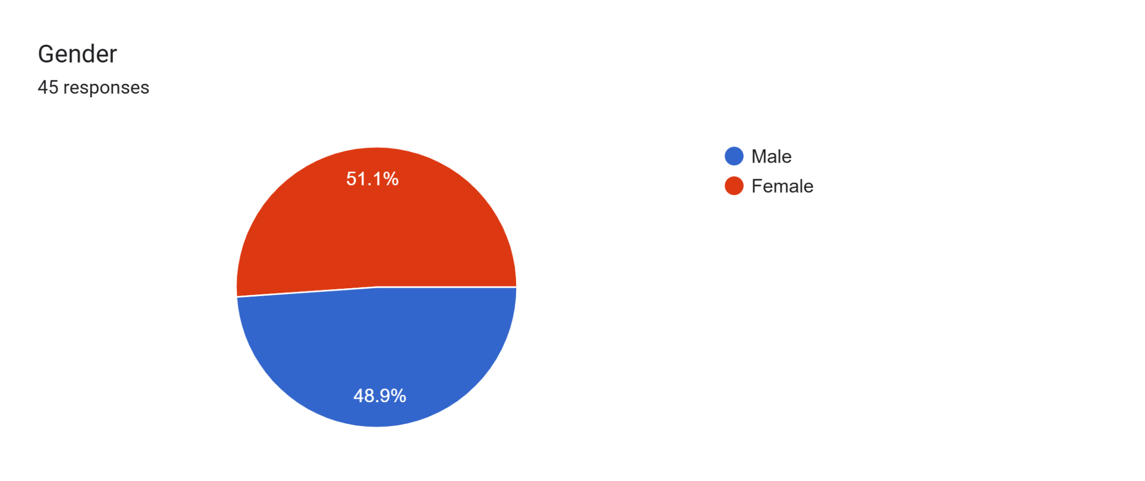

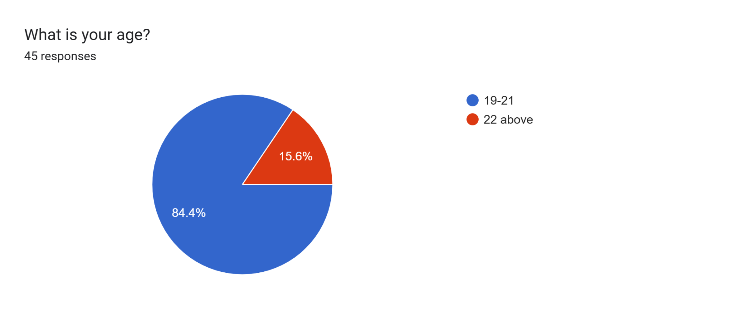

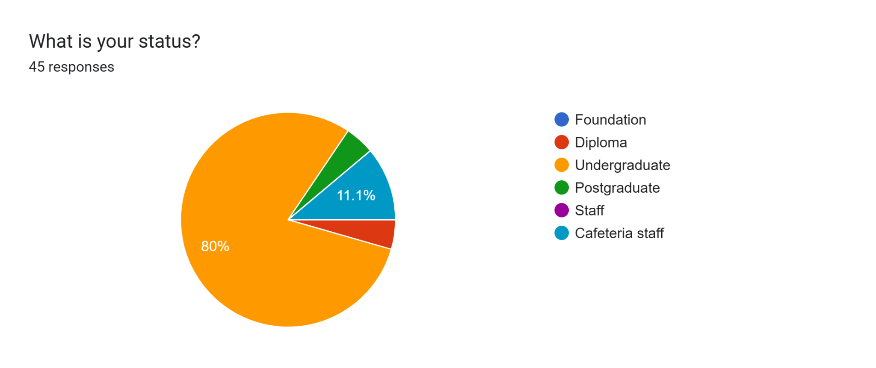

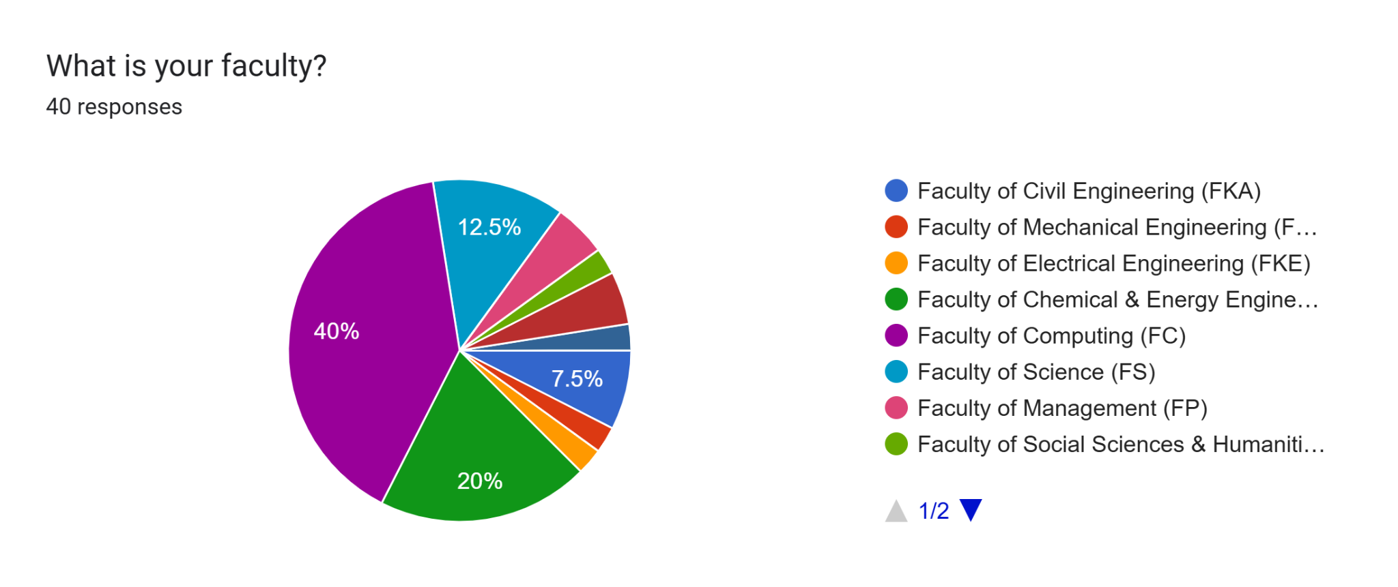

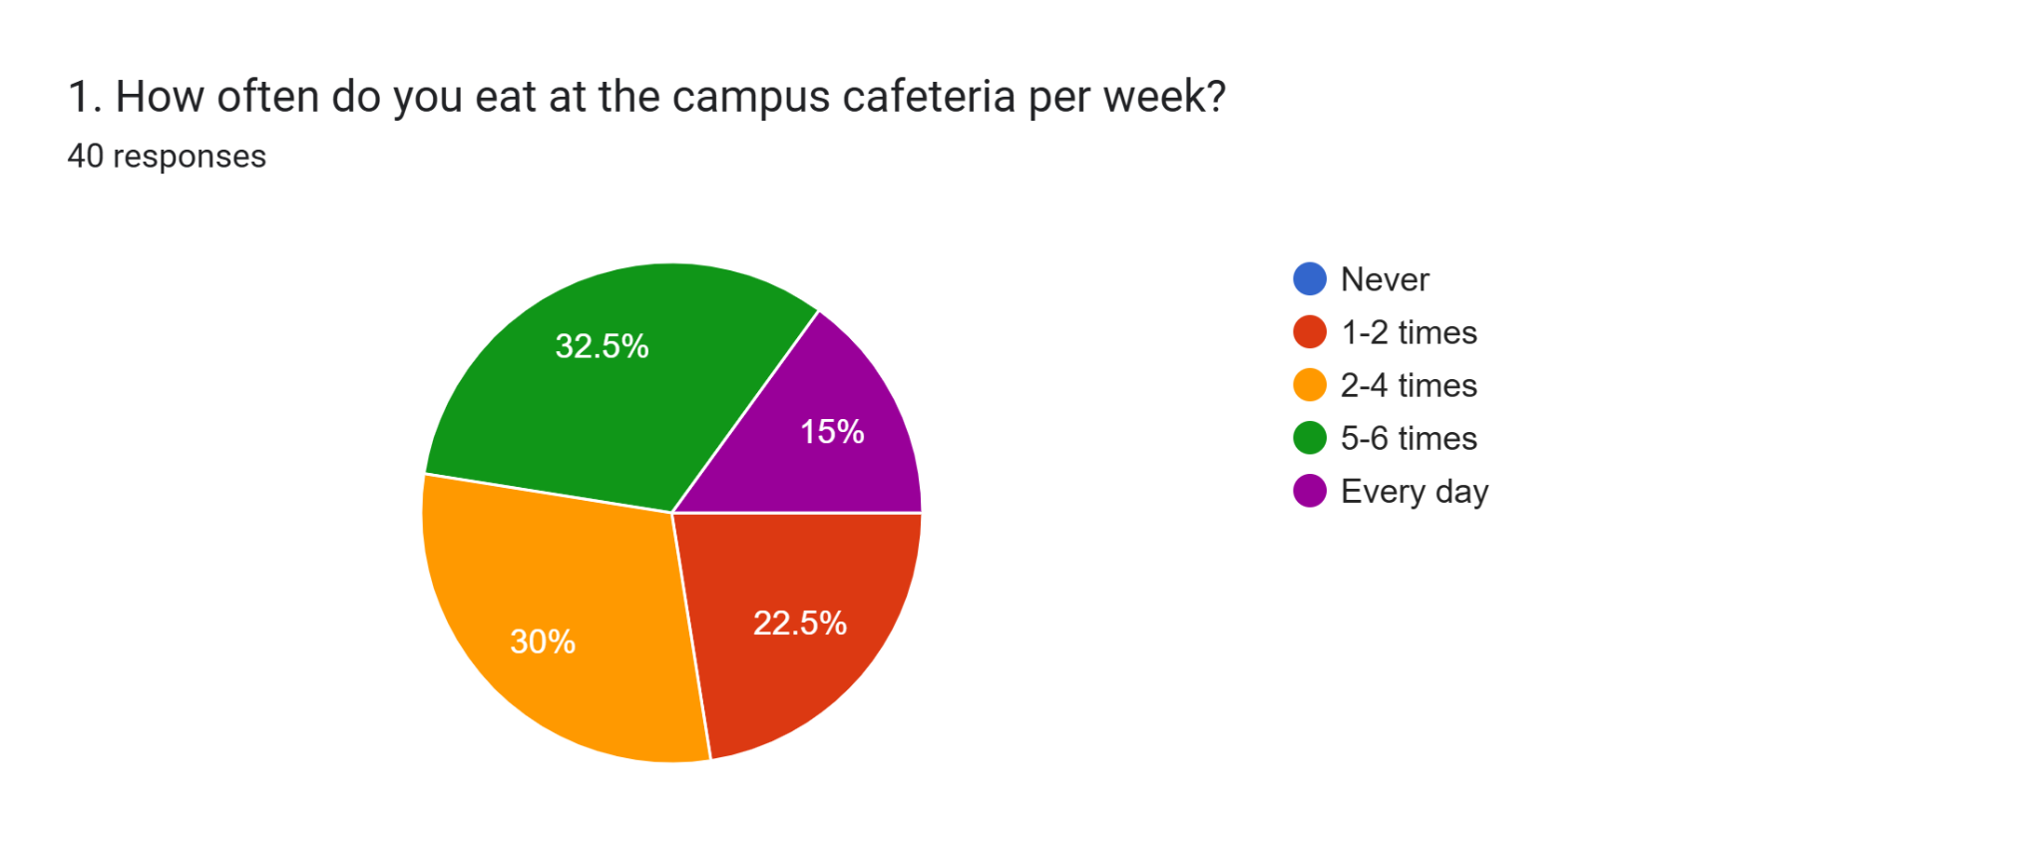

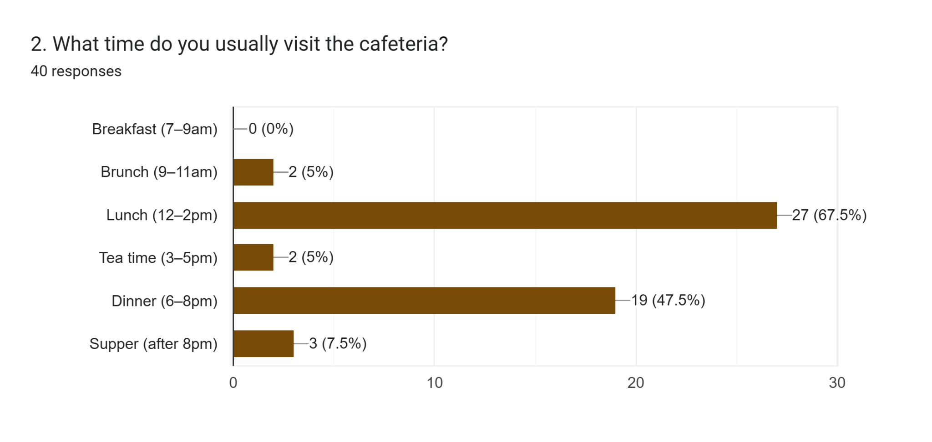

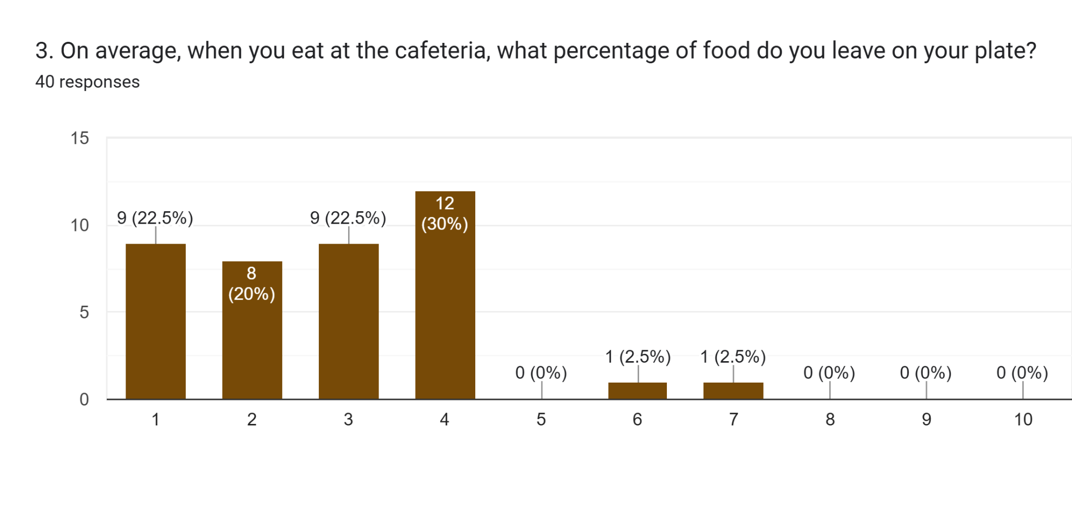

Forms response chart. Question title: 4. If you don't finish your food, what is the main reason?
. Number of responses: 40 responses.

Forms response chart. Question title: 5.Would you like the first serving to be smaller if you could easily ask for more food later?
. Number of responses: 40 responses.

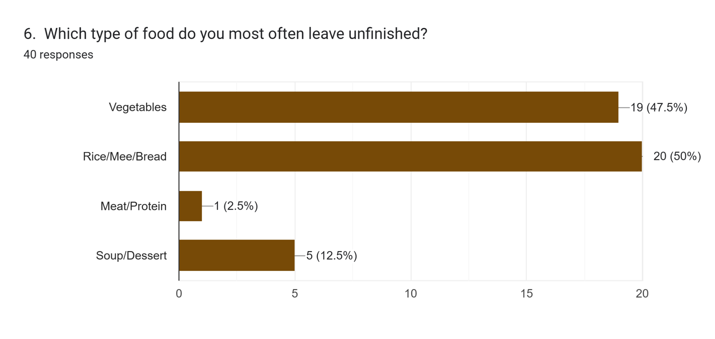

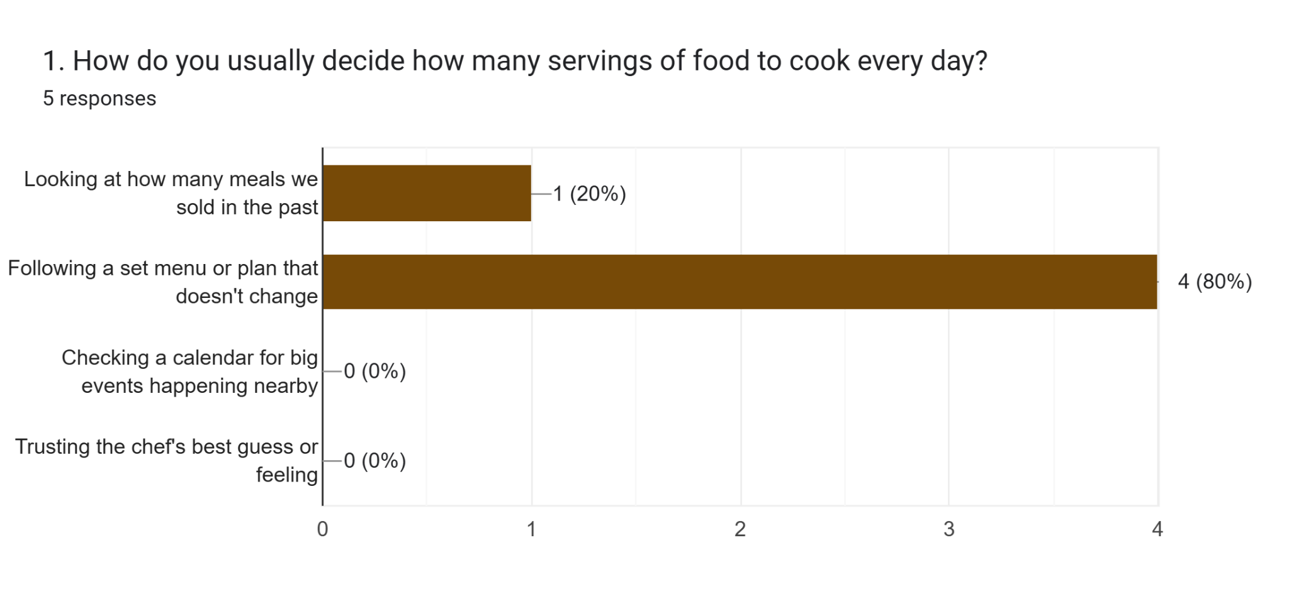

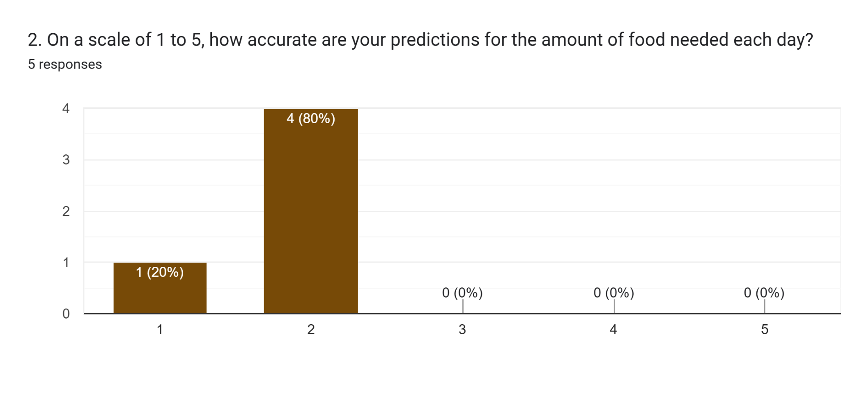

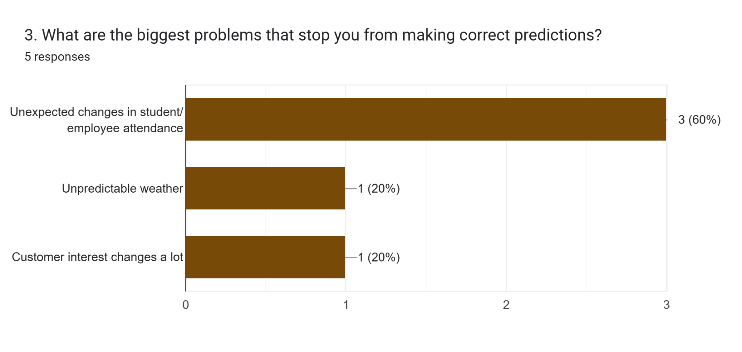

Forms response chart. Question title: 4. If you knew the exact number of customers 24 hours before, would that help you throw away less food?
. Number of responses: 5 responses.

1. Interview

The interview questions and answers are shown in the table below.

| **Questions** | **Answers** |
| --- | --- |
| How often do you finish your entire meal? | Not that often because sometimes I find myself wasting food, and I find it pretty much annoying. |
| What is the main reason you leave food on your plate? | I think it’s mostly because when I’m picking my food, I overestimate the amount of food that I will eat. So, whenever I am picking some of my food, I’ll usually pick large portions, thinking that I will finish it. But after eating for a while, I realized that I’m no longer hungry anymore, and I feel that the rest I cannot finish, which leads me to waste more food. |
| Would you use an app to see the menu and pre-order your meal? | I think that would be a great idea if that could help me stop wasting food. I hope that in the system they can recommend me to the appropriate serving size so that I won’t be able to waste food. |

Table 5.2.2.1 Interview Questions and Answers

ii. Define

Some issues that users have encountered are displayed in the table below.

| **Problems** | **Descriptions** |
| --- | --- |
| Ineffective food demand planning | Food waste at UTM cafeterias is caused by inaccurate demand forecasting and shifting student eating habits, which lead to over-preparation or food shortages. |
| Lack of planning data | Lack of precise data on student attendance and peak dining times makes it difficult for UTM cafeteria staff to plan food quantities and ingredients. |
| Changing student dining habits | Students frequently take more food than they can eat, which contributes to food waste and has an effect on the environment and finances in the absence of a system to encourage mindful consumption. |

Table 5.2.2.2 Problems and Descriptions

iii. Ideate

The potential solutions for users' issues are displayed in the table below.

| **Problems** | **The ‘Re-Saji’ Mobile Application** |
| --- | --- |
| Ineffective food demand planning | By enabling students to book their dining time at cafeteria by choosing the cafeteria, dining time, and portion size, our mobile app for dining reservations with QR codes ensures that food is prepared in accordance with actual demand and minimizes overproduction. |
| Lack of planning data | By tracking reservations and analyzing popular dishes, portion sizes, and peak times through an AI-based data analysis, the app helps cafeterias reduce food waste and increase efficiency by learning demand patterns over time. |
| Changing student dining habits | Instead of using an online payment system, our app uses a token-based system in which students spend a token for each booking and earn or lose tokens based on whether or not they finish their food, which is monitored by an AI image recognition model. This system of rewards and penalties promotes eating responsibly and lessens food waste. |

Table 5.2.2.3 Possible solutions to solve the problems

iv. Prototype

| **Features description** | **Prototype** |
| --- | --- |
| After launching the application, users were able to see a list of cafeterias that are open. The user selects a preferred cafeteria. After that, the system displays a list that shows the current buffet list. |  |
| Users book specific dining slots and choose portion sizes (Small, Standard, or Large). This allows the system to calculate the exact volume of food required before production begin |  |
| To secure a booking, the system requires a reservation fee of 1 token. This serves as a commitment to ensure the student intends to show up. |  |
| The reservations are done through a special QR code system once the users confirm the reservation to ensure that the data for attendance is recorded at the cafeteria entrance. |  |
| When users reach the selected cafeteria during their time slot, they scan the QR code and collect the food. The users go to the cafeteria counter to make payments using either physical funds or online bank transactions through a QR code at the cafeteria. |  |
| Using the “Scan Plate” camera API, users scan their plates post-consumption. The system uses image recognition to estimate the specific weight of leftovers and identifies which types of food remain unconsumed. Users with clean plates are rewarded with a token, while those with significant leftovers face deductions to encourage sustainable behavior. To maintain data accuracy, if a user fails to attend their scheduled dining time, the system permanently deduct their token. This penalty discourages “ghost reservations” that lead to over-preparation by the kitchen |  |
| The kitchen dashboard provides staff with a precise count of expected diners by analyzing real-time reservations, weather conditions, and university academic calendar. |  |
| To ensure total waste system accuracy, staff manually input the weight of unsold food at the end of the operating day. |  |
| Staff can view the specific types of food being left on plates (e.g., identifying that users are consistently leaving some rice) and unsold food data input by the staff. |  |
| Re-Saji Assistant helps staff to predict and plan food production for the following day by analyzing the historical waste trends, upcoming reservations, weather forecast and university calendar (e.g., exams). |  |

v. Test

We did a survey using Google form to get user feedback about the ‘Re-Saji’ mobile application. Based on the survey, most people think that it is good at helping cafeteria staff to predict the number of students. They also acknowledge that food waste in UTM cafeterias can be lessened by using weather and historical trends. All of the interviewees are satisfied with the features of the prototype. Some feedback including adding a feature for students to complain about the food. Besides, an interviewee also wants to know about cafeteria crowd levels.

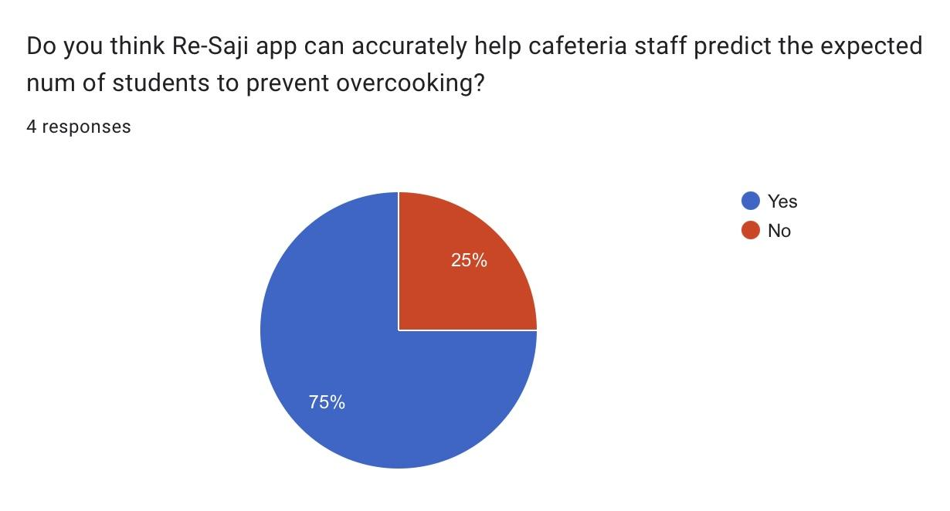

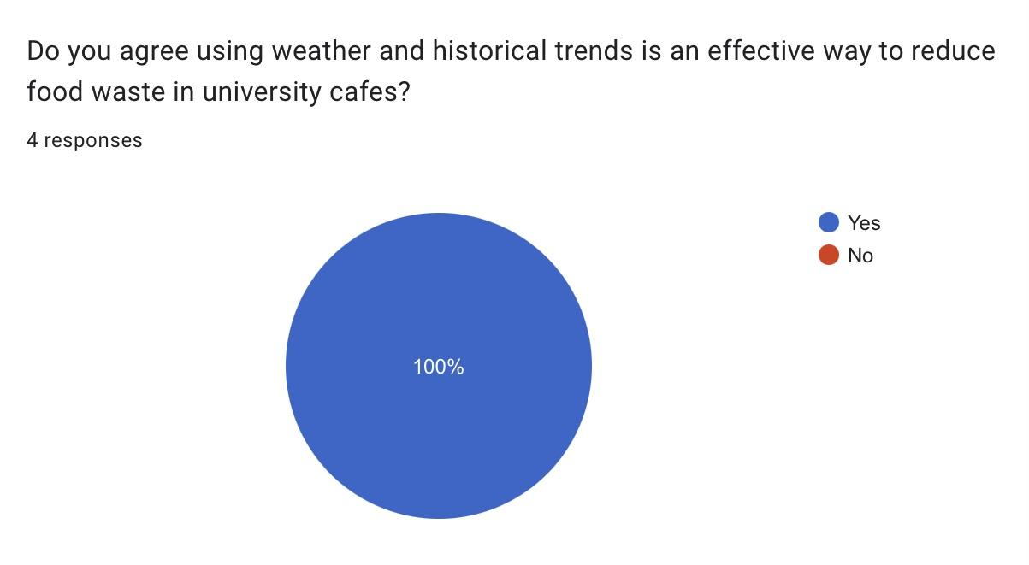

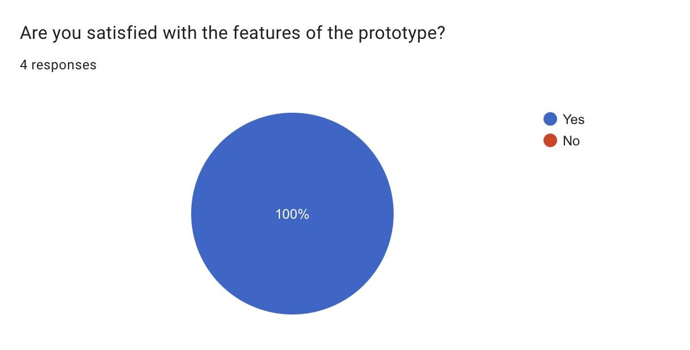

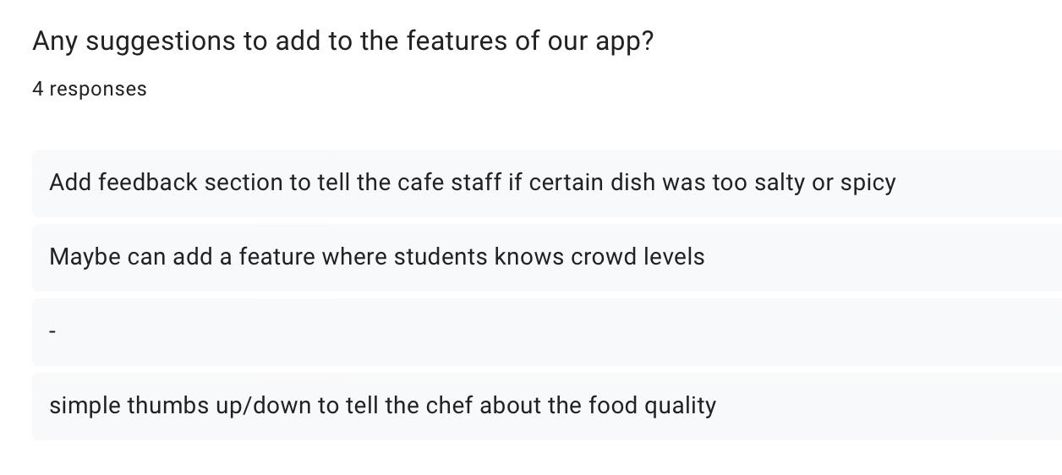

# **6. Reflection**

| **Group Members** | **Reflection** |
| --- | --- |
| Cheng Zhi Min | **What is your goal/dream with regard to your course/program?**  What I hope to accomplish from taking this data engineering course is to learn how to acquire data, handle data, and make effective use of data to help resolve problems. What I hope to become more proficient at is data quality concepts, databases, and data analysis so that the data used is accurate, safe, and relevant. Someday, I hope to apply these things that I learn to make improvements on systems or services. |
| **How does this design thinking impact on your goal/dream with regard to your program?**  This experience with design thinking taught me how real data can be used to solve problems. For instance, the Re-Saji prototype relied on information derived from real users to make wise decisions. This is exactly what I want to do as a data engineer. I want to create solutions that really work and help people. The Re-Saji app was yet another example of the potential of data to solve problems. |
| **What is the action/improvement/plan necessary for you to improve your potential in the industry?**  To have a future in this field, I will work on getting better at SQL, programming, and data analysis. Besides, I will do more projects to get some experience. This way, I can also figure out how to use my time well. Moreover, I need to stay updated with the technology. This will help me get ready for the challenges in this field. |
| Farah Aisya Binti Jaafar | **What is your goal/dream with regard to your course/program?**  My goal in Computer Science (Data Engineering) is to build strong skills in Python and SQL. I want to develop my critical thinking so I can prepare myself in advance to handle the real world problems during my internship. Learning these tools will help me create practical solutions for a successful career in the industry. |
| **How does this design thinking impact on your goal/dream with regard to your program?**  Design thinking changes my approach by making me think about people before technology. I must check if my ideas are practical, logical, and suitable for users. This process improves my critical thinking and prepares me for difficult workplace challenges that need both technical skills. |
| **What is the action/improvement/plan necessary for you to improve your potential in the industry?**  To improve my industry potential, I will get a professional cloud certification such as AWS and Azure. I will update my GitHub regularly with my data projects to show my work. I will also be active on LinkedIn by sharing my learning and connecting with others data engineers. |
| Muhammad Hafizuddin Hakimi Bin Hasmadi | **What is your goal/dream with regard to your course/program?**  I want to develop technology that can solve real problems. |
| **How does this design thinking impact on your goal/dream with regard to your program?**  It trained me to think beyond coding and consider user needs, sustainability, and impact. |
| **What is the action/improvement/plan necessary for you to improve your potential in the industry?**  I will involve myself in hackathons where I can meet new people and learn by building together. |

Table 6.1 Reflection of Each Member

# **7. Conclusion**

The 'Re-Saji' application was made to solve the problem about food that gets thrown away in cafeterias. The application is a way to deal with this issue. It uses data to help. It makes running a cafeteria easier and more efficient for the cafeteria staff. The application is extremely useful for students as well as for cafeteria staff.

The application consists of two components, which are the reservation system and the kitchen dashboard. The kitchen dashboard analyses the calendar, as well as the environment, past data, to determine the number of students who may attend. We also included the "Scan Plate" camera. It uses an AI-integrated image recognition software. The software assists the cafeteria management in understanding the preferences of students by analyzing the leftover food. The kitchen dashboard assists in determining the number of attendances.

Overall, some issues had to be encountered by our group members during this project. Our first designs were not very effective. Still, we made continuous progress because of effective communication. We had physical meetings. We even had WhatsApp conversations for discussion. This project served as an opportunity for us to apply the knowledge acquired in the class to address an actual issue. We look forward to enhancing ‘Re-Saji’ to achieve a sustainable and efficient food system.

# **8. Reference**

IxDF - Interaction Design Foundation. (2016, May 25). *What is Design Thinking?*. IxDF - Interaction Design Foundation. <https://www.interaction-design.org/literature/topics/design-thinking>

IDEO U. (2025, March 27). *What is design thinking & why is it beneficial?* IDEO U. <https://www.ideou.com/blogs/inspiration/what-is-design-thinking>

Han, E. (2022, January 18). *What is design thinking & why is it important?* HBS Online. <https://online.hbs.edu/blog/post/what-is-design-thinking>

Dam, R. F. (2025, July 18). *The 5 Stages in the Design Thinking Process*. IxDF - Interaction Design Foundation. <https://www.interaction-design.org/literature/article/5-stages-in-the-design-thinking-process>

Video Link: <https://youtu.be/mUzldjjr6ts>